マスクとてあらい
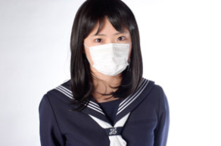
１Do you wear a mask when you go out?
Since the coronavirus pandemic began, many people around the world have started to wear face masks. They are worn not only by medical staff but also by ordinary people when they go out. In some countries, it's almost expected out of courtesy and safety to wear a mask. Do you have to wear a mask when you go outside?
In Japan, wearing a face mask is not a new custom. Japan has been producing masks to protect people from inhaling dust and becoming infected with viruses over 100 years. Recently, a wide variety of masks have become available. For example, there are close-fitting masks, scented masks, masks designed for summer, and other types.
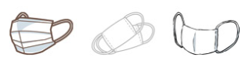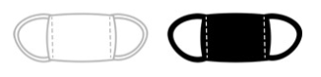
２Make a mask with everyday materials - Ask your teacher which one (A or B) you should work on.
Have you ever made origami paper crafts? You can make a mask in the same way. Watch the video and answer the following questions.
A: ハンカチマスク
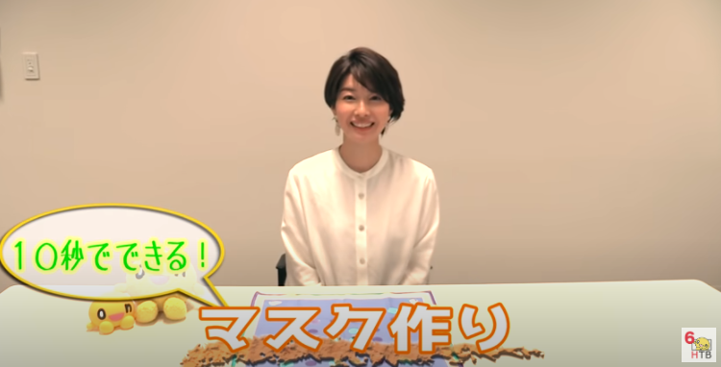

https://www.youtube.com/watch?v=PGug3ZZPp_k
- What materials do you need?__________________________________________________
- What is the first thing you need to do?___________________________________________
- What is the second thing you need to do?________________________________________
- How do you use the elastic bands? _____________________________________________
- What is the last thing you need to do?____________________________________________
Now let’s make a mask! Prepare the materials you need. Watch the video again and follow the instructions. Once your mask is done, wear it and show it to your family, teachers, and friends.
B: キッチンペーパーマスク
Watch the video and answer the following questions.
https://www.youtube.com/watch?v=c7-oE_xBDSA
- What materials do you need?__________________________________________________
- What is the first thing you need to do?___________________________________________
- What is the second thing you need to do?________________________________________
- What is the last thing you need to do?___________________________________________
- Now, let’s make a mask. First, draw a picture or write a message on the paper towel you are using. What kind of message would you like to write? Once you finish drawing or writing your message, watch the video again and make your own mask. Once it’s done, wear it and show it to your family, teachers, and friends.
Note: Wearing a handmade mask does not completely protect us from dust and viruses, but it helps to prevent the spread of infection. https://sonaeru.jp/goods/handiwork/groceries/g-11/
3 Wash your hands really well
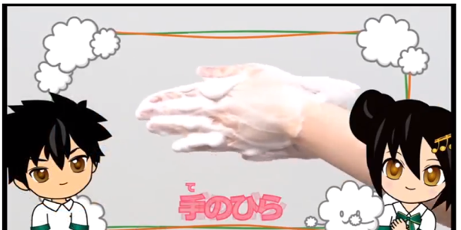
Along with wearing a mask, washing your hands is another important step to stop germs from spreading. Think about what you touched today—
your iPad, your phone, door knobs, pets, puzzles, etc. Whatever you touched may have had germs on it. It is easy for a germ to get from your hands to your mouth, so washing your hands is one of the most important things you can do to protect yourself from getting sick. But how should we wash our hands? Let’s learn an effective way to do it!

First, let’s watch the video. http://www.pref.tochigi.lg.jp/c05/tib/5ch/kenko/024.html

おみずをかけましょう りょうてにしっかりと
せっけんつかって あわあわ ブクブク あわだてよう
てのひら ごしごし てのこう ごしごし ゆびのあいだも わすれずに
おやゆび きゅッきゅっキュー ゆびさき ごしごし てくびを くるくる よくあらおう
お水でしっかりながしましょう お水でしっかりながしましょう
きれいなハンカチでてをふこう

- Number the actions in the correct order in Japanese as seen in the video. The first one and the last one have been done for you. You can watch the video again if you like.
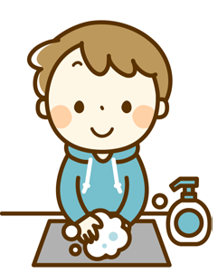
一 | Wet your hands and turn off the tap.
 | Wash your thumbs.
 | Wash the tips of your fingers.
 | Rinse the lather off with running water and turn off the tap.
 | Wash between your fingers.
 | Using soap and lather up your hands.
 | Wash your palms and the back of your hands.
 | Wash your wrists.
九 | Dry your hands with a clean handkerchief.
- Once you have the correct order, write the actions down on a big piece of paper. Add some pictures if you like. Put the paper up where you wash your hands so that it reminds you and your family how to do it in an effective way.
- How is this different from the usual way you wash your hands?
____________________________________________________________________________________________________________________________________________________________________
- Watch the video again. Did you hear the following words in the song? Match each word to the correct action.
1 | 2 | 3 | 4 | 5
ざぶざぶ | あわあわ ブクブク | ゴシゴシ | キュッキュッ | クルクル
Frothing up the soap | Washing the wrists with a twisting motion | Wetting the hands with water | Scrubbing the hands and fingers | Washing the thumbs until squeaky clean
For online quizzes, go to https://www.studystack.com/quiz-3230554 and https://www.studystack.com/studyslide-3230552
- These words are called onomatopoeias and they are used to imitate sounds. Japanese onomatopoeias are also used for things or actions that don't normally make any noise.
- What have you noticed about these Japanese onomatopoeias?
- Have you seen other Japanese onomatopoeias before?
- Let’s watch Arashi, a popular Japanese idol group, dance and show the proper way to wash your hands. https://www.youtube.com/watch?v=jSM0h8VPSZk
