Mottainai Baasan and Furoshiki Wrapping
-Living with the Environment in Mind-
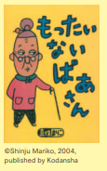
Section A: Let’s watch a video of Mottainai Baasan
Have you heard about Mottainai Baasan (Mottainai Grandma)?
Mottainai Baasan appears out of nowhere when we are doing something wasteful, and shows us how to change our habits.

Watch a Mottainai Baasan video in Japanese and answer the following questions.

Watch the Mottainai Baasan video いただきますin Japanese and answer the following questions. https://www.youtube.com/watch?v=k59r4AnJgU8
If you want to watch the English version to answer the questions, go to https://www.youtube.com/watch?v=M184dGeiDks
- What does the girl say before eating? What does it mean?
________________________________________________________
- What is the Japanese word she uses to express that she doesn’t like something? Write the word in the boxes in hiragana.

- Label the items in Japanese by choosing the correct word for each.
やさい ピーマン さかな きのこ ごはん にんじん

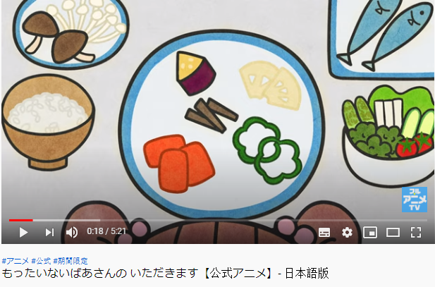

- Write the answers for A, B, C, and D in the table below. The first column is done for you.
- Which foods does she dislike? Which foods does she like? Write すき for her favorite foods, and きらいfor the ones she doesn’t like.
- Write the English name of each food.
- What nutrients are contained in each food? Choose the main nutrients from below and write them in each column.
Protein/ Vitamins/Carbohydrates/Minerals/Calcium/Fat
- What did Mottainai Baasan say about how each food group helps you?
 | Foods in Japanese | にんじん  ピーマン | さかな  にく  ぎゅうにゅう まめ | わかめ  ひじき  きのこ | いちご  りんご  バナナ  みかん | ごはん  パン  うどん  そば
A | すき or  きらい | きらい
B | In English | carrot  capsicum (or bell pepper)
C | Nutrients | vitamins
D | How do they help? | Help people to grow stronger
- How did Mottainai Baasan explain the word “mottainai”? Share your answers with your classmates.
________________________________________________________________
________________________________________________________________
________________________________________________________________

Section B: Let’s practice using furoshiki

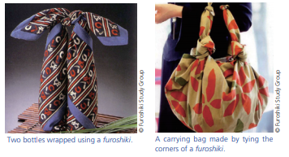
Furoshiki are used in traditional methods of wrapping or bundling in Japan. These square cloths come in different sizes, and can be tied in various ways to carry items of assorted sizes and shapes. Furoshiki can be folded flat when not in use. They are receiving renewed attention because they are both handy and reusable.
The Japan Forum magazine TAKARABAKO No20

Let’s practice using furoshiki. Follow the instructions to wrap two bottles with one furoshiki in a way that allows you to carry it like a bag. Use a square cloth such as a scarf (about 70cm x 70cm is best).
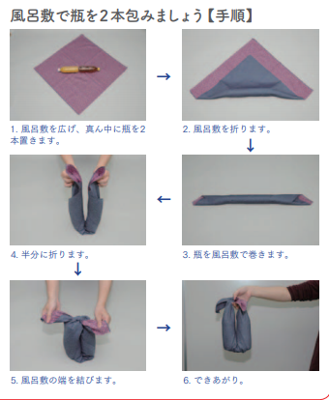
6 Done!
5 Tie the ends together.
4 Fold it in half.
3 Roll up the bottles with the furoshiki.
2 Fold the furoshiki diagonally.
1 Place two bottles in the center of the furoshiki.

If you want to learn other ways of using furoshiki, you can watch the following video: https://www.youtube.com/watch?v=pnLZOj5V-f8

Show your furoshiki to your friends and family when it’s done! You can teach them how to use one, too!
Section C: How many “Ecology 3Rs” do you know?
- You probably know that the 3Rs of sustainability stand for “Reuse, Reduce, Recycle.” However, three is not enough. There are many more Rs!
The following website describes 18 Rs of sustainability. (22世紀を生きる君へ－For those who will live in the 22nd century)
https://22nd-century.jp/environment-issues/3r4r5r/
Go to the website and write down all the 18Rs in the chart below. If you have learned Katakana, write them in English and in Katakana, as shown on the website.
Then give points according to what you do or what you don’t do.
- いつもする (I always do this) 3てん
- ときどきする (I sometimes do this) 2てん
- しない (I never do this) 0てん
- これからしようと思う (I will do this from now on) 1てん
 | かんきょうのRs | とくてん (points)
1
2
3
4
5
6
7
8
9
10
11
12
13
14
15
16
17
18
 | Total points
- How many points did you get? Compare with your classmates. Who is the winner in your class?
- Highlight the ones you marked これからしようと思う (I will do this from now on), and write them down on a big piece of paper. Put this up on the wall to remind yourself and other people of new ways to help the environment.
- Discuss how you can improve the environment in and around your school. Create a poster to encourage people to help the environment, then take action. For example, present your ideas to the school council or the principal.
About Mottainaiもったいない: The Japanese word mottainai is said to have originated in Buddhism, to express the grief one feels when an object ceases to be the way it should. Today, the word is used as a kind of protest against waste, and regret that its true value was not put fully to effect. When Wangari Muta Maathai of Kenya visited Japan in 2005, the year after she became the first African woman to receive the Nobel peace prize for environmentalism, she came across with the word mottainai for the first time. Ms. Maathai was deeply impressed by the word, which not only expresses the principle of the 3Rs, but is also filled with compassion, gratitude, and respect for nature and everything in it. She later proposed at the United Nations Commission on the Status of Women held at the U.N. headquarters in New York to embark on a global mottainai campaign to use natural resources more effectively, which led to the beginning of the global-scale mottainai campaign. In Japan, the Asahi Shimbun Company opened a mottainai campaign headquarters, expanding the movement into many different fields with the help of numerous corporations and organizations. Mottainai website: http://mottainai.info.
The Japan Forum magazine TAKARABAKO No20

Other videos of Mottainai Baasan
Mottainai Baasan (Official)
https://www.youtube.com/watch?v=x5Wz7FCW9Zk (Japanese)
https://www.youtube.com/watch?v=KdKr-JSMJP4 (English)
Mottainai Baasan Goes to the River
https://www.youtube.com/watch?v=Cu1Y7Z3iijM (Japanese)
https://www.youtube.com/watch?v=p1MYVlIgYnU (English)

For the articles in “Living with the Environment in Mind,” go to:
https://www.tjf.or.jp/clicknippon/ja/archive/docs/TB20_E.pdf (English)
https://www.tjf.or.jp/clicknippon/ja/archive/docs/TB20_J.pdf (Japanese)

If you want to learn other ways of using furoshiki, there are many instructional videos available online. The following video is easy to follow: https://www.youtube.com/watch?v=pnLZOj5V-f8

