Mottainai Baasan and Furoshiki Wrapping
-Living with the Environment in Mind-
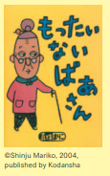
Section A: Let’s watch a video of Mottainai Baasan
Have you heard about Mottainai Baasan (Mottainai Grandma)?
Mottainai Baasan appears out of nowhere when we are doing something wasteful, and shows us how to change our habits.

Watch a Mottainai Baasan video in Japanese and answer the following questions.
https://www.youtube.com/watch?v=x5Wz7FCW9Zk
(If you want to watch the English version to answer the questions, go to: https://www.youtube.com/watch?v=KdKr-JSMJP4)

- What do you think “mottainai” means in English? _____________
- What are the 5 mottainai things that the boy did in the video? What is Mottainai Baasan’s advice for each action?
 | Mottainai things that the boy did | Mottainai Baasan’s advice
1
2
3
4
5

- Do you keep the water running or stop the water while brushing your teeth? Which do you think is better for the environment? Why do you think so?

_________________________________________________________________
_________________________________________________________________
_________________________________________________________________

- What do you think Mottainai Baasan is saying in the picture below? Write in English in the speech bubble.
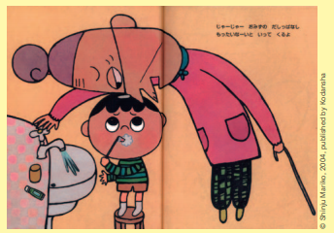

- Think of other situations in your everyday life where Mottainai Baasan would appear. List five situations. What advice do you think she would give you for each situation? You can discuss with your friends.

 | Mottainai things we do | Mottainai Baasan’s advice
1
2
3
4
5
Mottainai is the word used as a kind of protest against waste.
Let’s learn this word and be active to protect our environment!
もったいない！

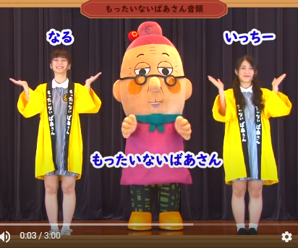
Section B: Let’s dance the Mottainai Baasan Ondo
Let’s dance the Mottainai Baasan Ondo. https://www.youtube.com/watch?v=KINDI0f9Mm0

Naru, Itchii, and Mottainai Baasan are showing how to dance the Mottainai Baasan Ondo. Ondo is a traditional Japanese style of music. Usually, the main singer sings the whole song, and the dancers sing the chorus.
Dance to the song and sing along with the chorus!

For those who are interested in the meaning of the song, the lyrics are provided below.
Japanese lyrics | English meaning of the song
Chorus:  もったいないこと してないかい  Mottainai koto shite nai kai  もったいないこと してないかい  Mottainai koto shite nai kai  もったいない もったいない  Mottainai Mottainai  もったいないこと してないかい  Mottainai koto shite nai kai  おさらのうえのたべのこし  ちゃわんについたごはんつぶ  わたしがたべてもいいのかい  ぱくぱく ごくごく ぺろぺろりん  じゃあじゃあ おみずのだしっぱなし  かみをまるめて ぽいぽいぽい  みかんのかわも すてるのかい  もったいないばあさん くるよ | Chorus:  Are you doing anything Mottainai (wasteful)?  Are you doing anything Mottainai (wasteful)?  Mottainai, Mottainai  Are you doing anything Mottainai (wasteful)?  The leftovers on the plate  The grains of rice stuck in the rice bowl  Is it OK if I eat them?  Paku paku goku goku pero perorin (sounds of eating)  Jaa jaa (sound of water running) Do you keep water running unnecessarily?  Do you scrunch and throw away paper wastefully? Poi poi poi (sound of mindlessly throwing something away)  Do you throw away mandarin orange peels too?  Mottainai Baasan will come and get you!

Section C: Let’s practise using furoshiki

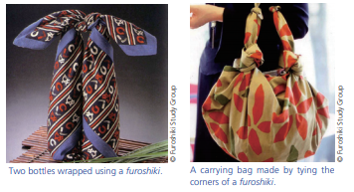
Furoshiki are used in traditional methods of wrapping or bundling in Japan. These square cloths come in different sizes, and can be tied in various ways to carry items of assorted sizes and shapes. Furoshiki can be folded flat when not in use. They are receiving renewed attention because they are both handy and reusable.
The Japan Forum magazine TAKARABAKO No20

Let’s practise using furoshiki. Follow the instructions to wrap two bottles with one furoshiki in a way that allows you to carry it like a bag. Use a square cloth such as a scarf (about 70cm x 70cm is best).
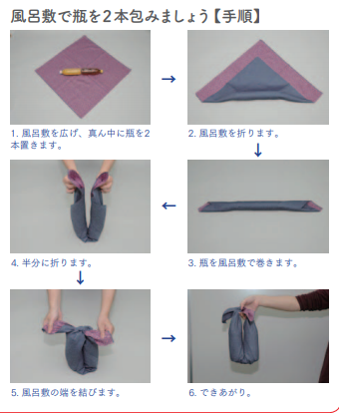
6 Done!
5 Tie the ends together.
4 Fold it in half.
3 Roll up the bottles with the furoshiki.
2 Fold the furoshiki diagonally.
1 Place two bottles in the center of the furoshiki.

If you want to learn other ways of using furoshiki, you can watch the following video: https://www.youtube.com/watch?v=pnLZOj5V-f8

Show it to your friends and family when it’s done! You can teach them how to use one, too!

